**Placement Details:**

**Central Of Tendency:**

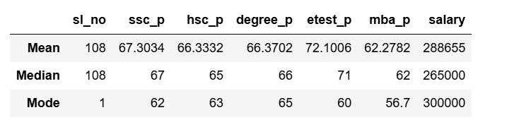

**From above analysis,**

* The students are got marks above average in SSLC, HSC and MBA examination.
* They got good marks in entrance test.
* The salary outlier is 20000, average salary is 265000 and most frequently occurring salary is 300000.

**Placement Details:**

**Percentile**

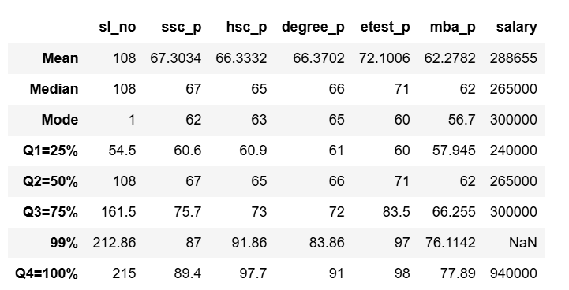

**From above analysis,**

**SSLC:**

* The first 25th percentile of students scored up to 60.6 marks (Q1).
* 50th percentile of students scored up to 67 marks (Q2), indicating a 7% improvement from Q1 to Q2.
* 75th percentile of students scored up to 75 marks (Q3), showing an 8% improvement from Q2 to Q3.
* All students scored up to 89 marks, with a 14% improvement from Q3 to the maximum score.

**HSC:**

* The first 25th percentile of students scored up to 60.9 marks (Q1).
* 50th percentile of students scored up to 65 marks (Q2), indicating a 4% improvement from Q1 to Q2.
* 75th percentile of students scored up to 73 marks (Q3), showing an 8% improvement from Q2 to Q3.
* All students scored up to 97 marks, with a 25% improvement from Q3 to the maximum score.

**Degree:**

* The first 25th percentile of students scored up to 61 marks (Q1).
* 50th percentile of students scored up to 66 marks (Q2), indicating a 5% improvement from Q1 to Q2.
* 75th percentile of students scored up to 72 marks (Q3), showing an 6% improvement from Q2 to Q3.
* All students scored up to 91 marks, with a 19% improvement from Q3 to the maximum score.

**Entrance:**

* The first 25th percentile of students scored up to 60 marks (Q1).
* 50th percentile of students scored up to 71 marks (Q2), indicating a 11% improvement from Q1 to Q2.
* 75th percentile of students scored up to 83.5 marks (Q3), showing an 12% improvement from Q2 to Q3.
* All students scored up to 98 marks, with a 15% improvement from Q3 to the maximum score.

**MBA:**

* The first 25th percentile of students scored up to 58 marks (Q1).
* 50th percentile of students scored up to 62 marks (Q2), indicating a 4% improvement from Q1 to Q2.
* 75th percentile of students scored up to 66.25 marks (Q3), showing an 4% improvement from Q2 to Q3.
* All students scored up to 77.8 marks, with a 10% improvement from Q3 to the maximum score.

**Salary:**

* The first 25th percentile of student’s salary up to 240000 marks (Q1).
* 50th percentile of student’s salary up to 265000 marks (Q2), indicating a 10% improvement from Q1 to Q2.
* 75th percentile of students scored up to 300000 marks (Q3), showing an 15% improvement from Q2 to Q3.
* All students scored up to 940000 marks, with a 210% improvement from Q3 to the maximum score.

**Placement Details:**

**Inter Quartile Range:**

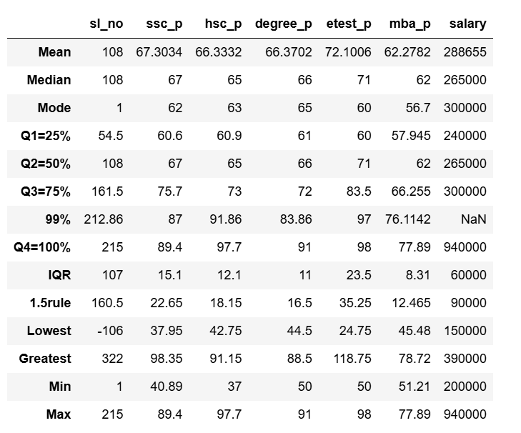

**SSLC:**

The minimum value 40.89 is above the lower bound 37.95. Hence, there is no outlier in this data.

The maximum value 89.4 is below the upper bound 98.35. Hence, there is no outlier in this data.

**HSC:**

The minimum value 37 is below the lower bound 42.75. Hence, there is outlier in this data.

The maximum value 97.7 is above the upper bound 91.15. Hence, there is outlier in this data.

**Degree:**

The minimum value 50 is above the lower bound 44.5. Hence, there is no outlier in this data.

The maximum value 91 is above the upper bound 88.5. Hence, there is outlier in this data.

**Entrance:**

The minimum value 50 is above the lower bound 24.75. Hence, there is no outlier in this data.

The maximum value 98 is below the upper bound 118.75. Hence, there is no outlier in this data.

**MBA:**

The minimum value 51.21 is above the lower bound 45.48. Hence, there is no outlier in this data.

The maximum value 77.89 is below the upper bound 78.72. Hence, there is no outlier in this data.

**Salary:**

The minimum value 200000 is above the lower bound 150000. Hence, there is no outlier in this data.

The maximum value 940000 is above the upper bound 390000. Hence, there is outlier in this data.